**Electrical Diagrams and Calculations:**

Here, for each floor and unit, we will show the switch board diagrams for main supply and emergency supply, and then show sub distribution board diagrams for main and emergency supply. The necessary calculations will be presented in tabular form.

For LED lights, we have chosen the maximum load, which is 20W, which in 100 lumen/Watt rate should give 2000 lumens of light each. This is greater than the value that we used in our lighting calculation, so there is a safe margin.

Supply line to neutral voltage has been assumed to be 220V and the power factor has been taken to be 0.9, which is reasonable for a residential building.

**Basement**

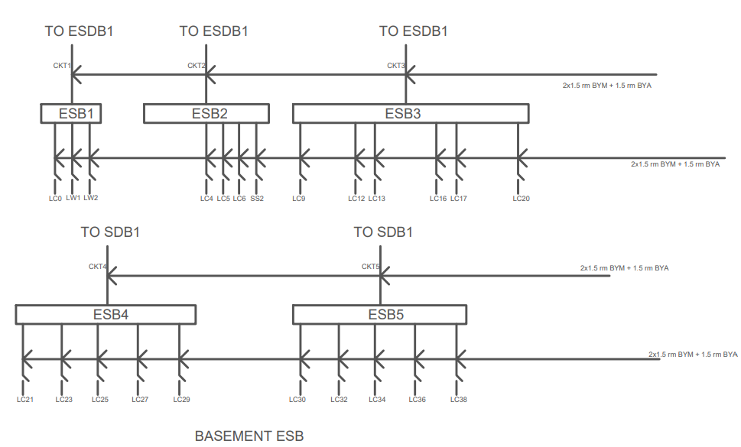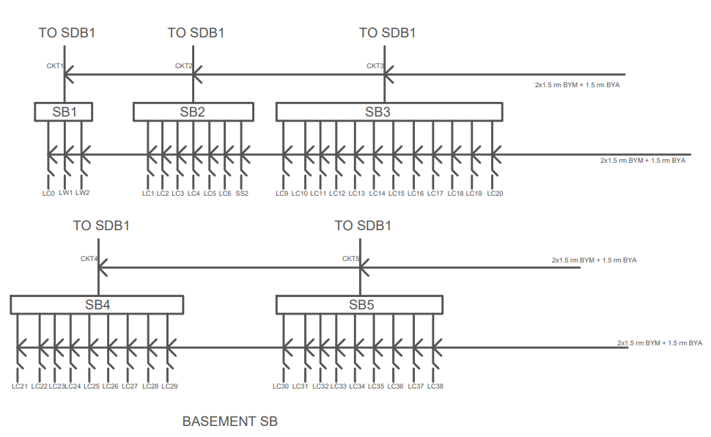Switch Board Diagram and Emergency Switch Board Diagram:

Calculations:

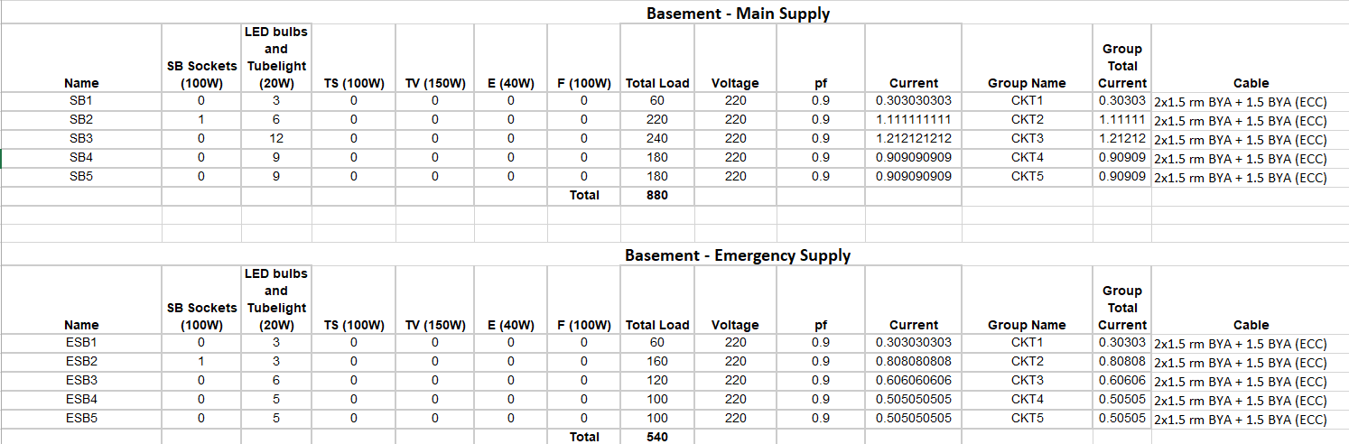

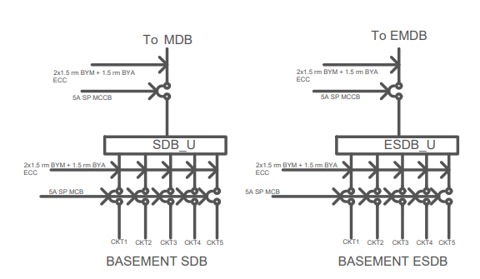SDB Diagram and ESDB Diagram:

**Calculation:**

For SDB_U, we notice that all switchboards are below 5A rating (similarly for the emergency case, as load is even lesser). Thus, standard 2 x 1.5 rm BYM cables and 1.5 BYA ECC cable has been used for connecting switchboards to SDBs, along with 5A MCB breakers.

We assume utility factor for normal load to be 0.7, assuming they would be operating 70% of the time. Power Factor = 0.9

**SDB_U:**

Load = 0.7 x total load = 0.7 x 880 = **616W** (No power sockets are present here)  
Current = 616/(220 x 0.9) = 3.11 A  
Thus, 2 x 1.5 rm BYM cables and 1.5 BYA ECC cable has been used, along with 5A **MCCB** breaker, to connect it to the MDB.

**ESDB_U:**

Load = 0.7 x total emergency load = 0.7 x 540 = **378W**  
Current = 616/(220 x 0.9) = 1.9 A  
Thus, 2 x 1.5 rm BYM cables and 1.5 BYA ECC cable has been used, along with 5A **MCCB** breaker, to connect it to the MDB.

**Ground**

Switch Board Diagram and Emergency Switch Board Diagram:

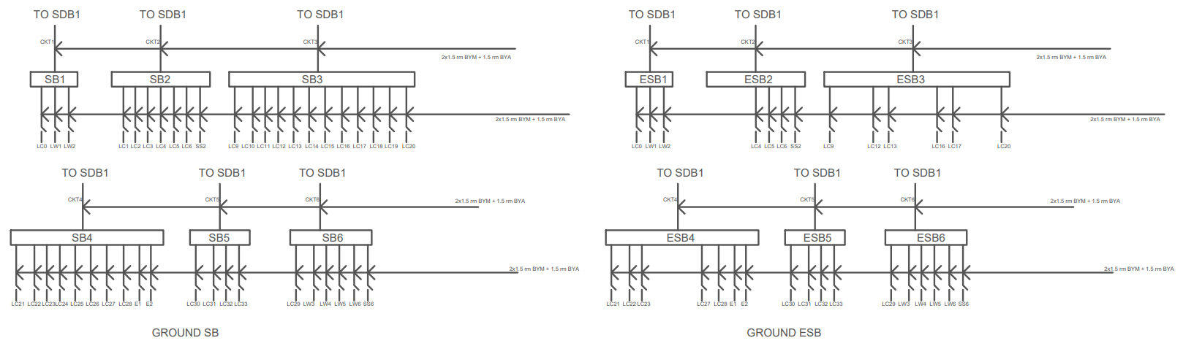

Calculations:

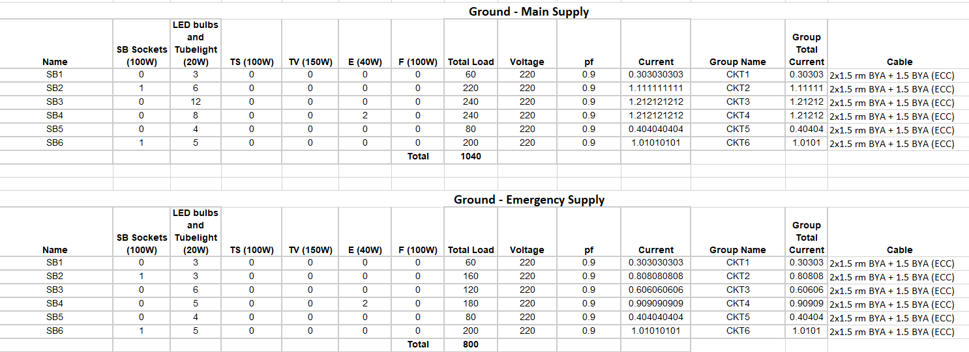

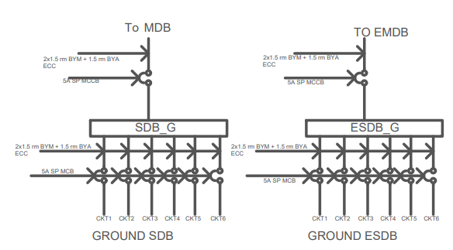SDB Diagram and ESDB Diagram:

**Calculation:**

For SDB_G, we notice that all switchboards are below 5A rating (similarly for the emergency case, as load is even lesser). Thus, standard 2 x 1.5 rm BYM cables and 1.5 BYA ECC cable has been used for connecting switchboards to SDBs, along with 5A MCB breakers.

We assume utility factor for normal load to be 0.7, assuming they would be operating 70% of the time. Power Factor = 0.9

**SDB_G:**

Load = 0.7 x total load = 0.7 x 1040 = **728W** (No power sockets are present here)  
Current = 728/(220 x 0.9) = 3.677 A  
Thus, 2 x 1.5 rm BYM cables and 1.5 BYA ECC cable has been used, along with 5A SP **MCCB** breaker, to connect it to the MDB.

**ESDB_U:**

Load = 0.7 x total emergency load = 0.7 x 800 = **560W**  
Current = 560/(220 x 0.9) = 2.83 A  
Thus, 2 x 1.5 rm BYM cables and 1.5 BYA ECC cable has been used, along with 5A SP **MCCB** breaker, to connect it to the MDB.

**Single Unit Floor**

Switch Board Diagram and Emergency Switch Board Diagram:

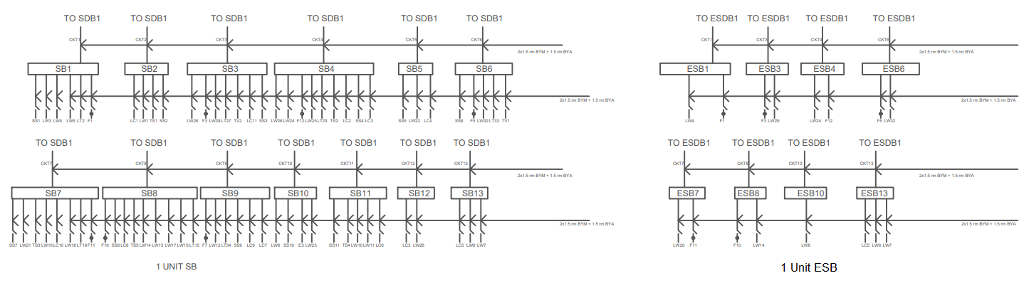

Calculations:

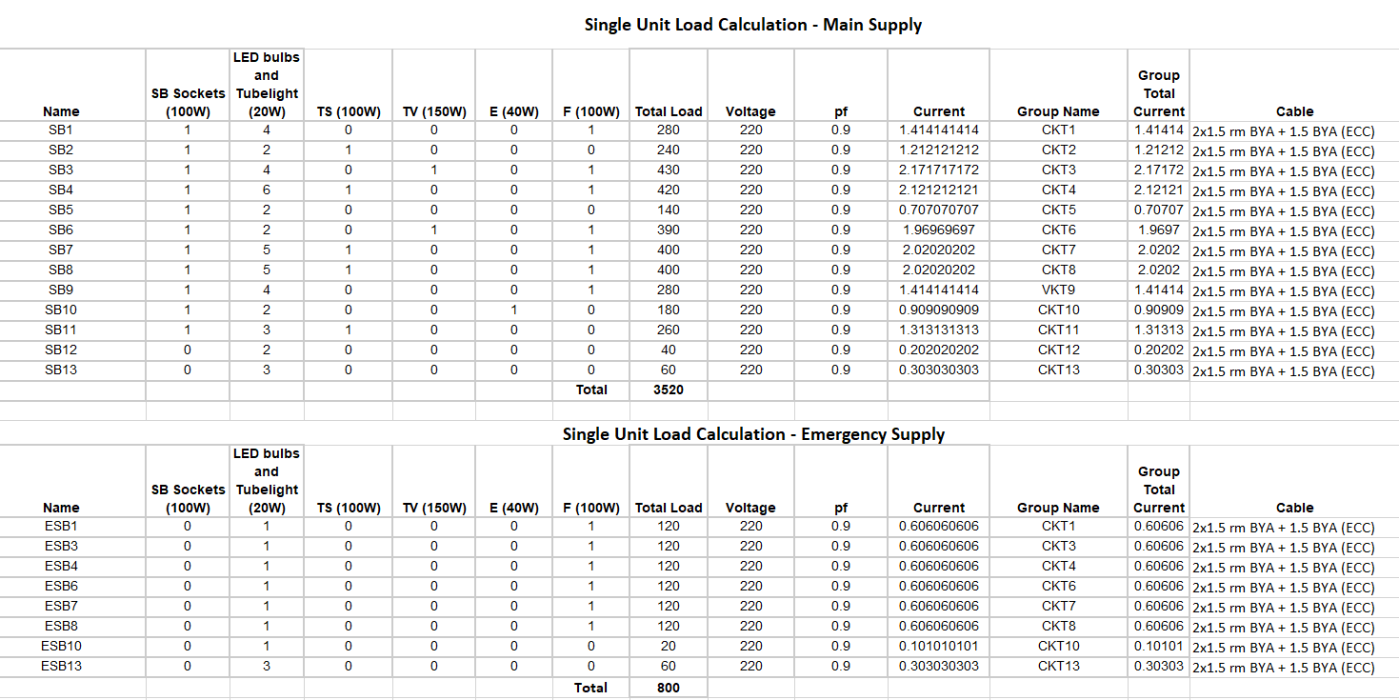

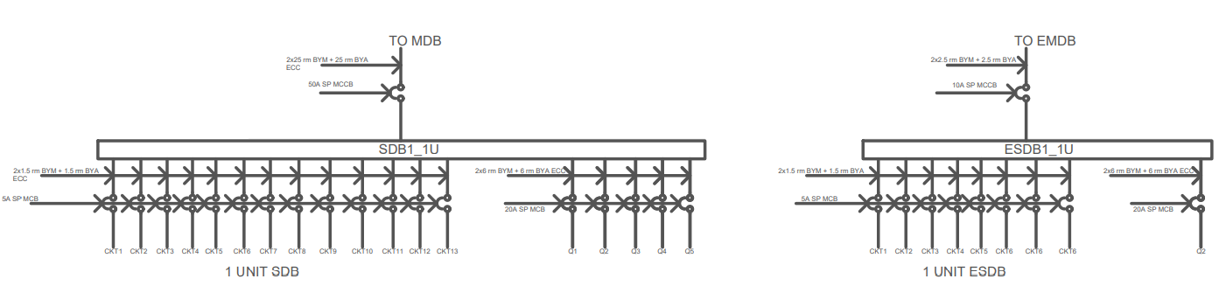SDB Diagram and ESDB Diagram:

**Calculation:**

For SDB_U1, we notice that all switchboards are below 5A rating (similarly for the emergency case, as load is even lesser). Thus, standard 2 x 1.5 rm BYM cables and 1.5 BYA ECC cable has been used for connecting switchboards to SDBs, along with 5A MCB breakers.

Here, power sockets with rating 20A and 4000W are present. (4000V/220A = 18.18A). Thus, we have used **20A SP MCB Breakers** and 2x6 rm BYM + 6 rm BYA ECC wires.

We assume utility factor for normal load to be 0.7, assuming they would be operating 70% of the time.

For a typical AC, watt rating is 1500 Watt. As our power socket is 4000W, the ratio is then 1500/4000 = 0.375. But an AC will not run all the time. If we assume it runs 80% of the time during summer, then our utility factor should be 0.8x0.375 = 0.3. Thus for power sockets, we assume utility factor to be 30%.

Here, power factor = 0.9

**SDB_U1:**

Load = 0.7 x total load + 0.4 x power socket load  
= 0.7 x 3520 + 0.3 x 4000 x 5 = **8464W** (5 Q sockets are present)  
Current = 8464/(220 x 0.9) = 42.75 A  
Thus, 2 x 25 rm BYM cables and 25 rm BYA ECC cable has been used, along with 50A SP **MCCB** breaker, to connect it to the MDB.

**ESDB_U1:**

For emergency condition, we will assume the power socket utility factor to be 0.2

Load = 0.7 x total emergency load + 0.2 x power socket load  
= 0.7 x 800 + 0.2 x 4000 = **1360W** (1 Q socket is present on emergency)  
Current = 1360/(220 x 0.9) = 6.87 A  
Thus, 2 x 2.5 rm BYM cables and 2.5 rm BYA ECC cable has been used, along with 10A SP **MCCB** breaker, to connect it to the MDB.

**Double Unit Floor – Unit 1**

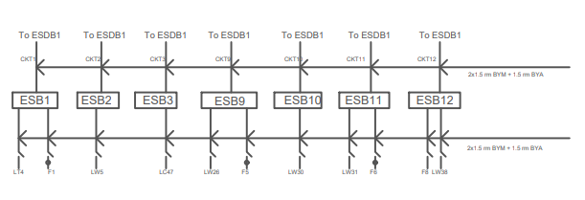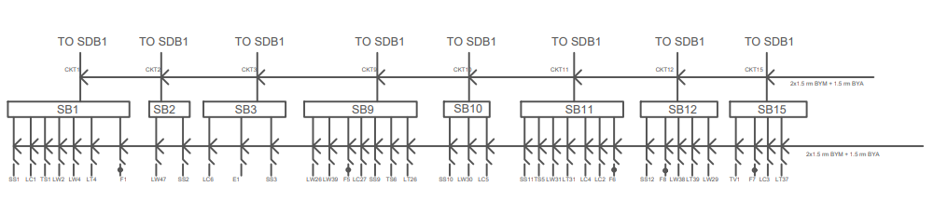Switch Board Diagram and Emergency Switch Board Diagram:

Calculations:

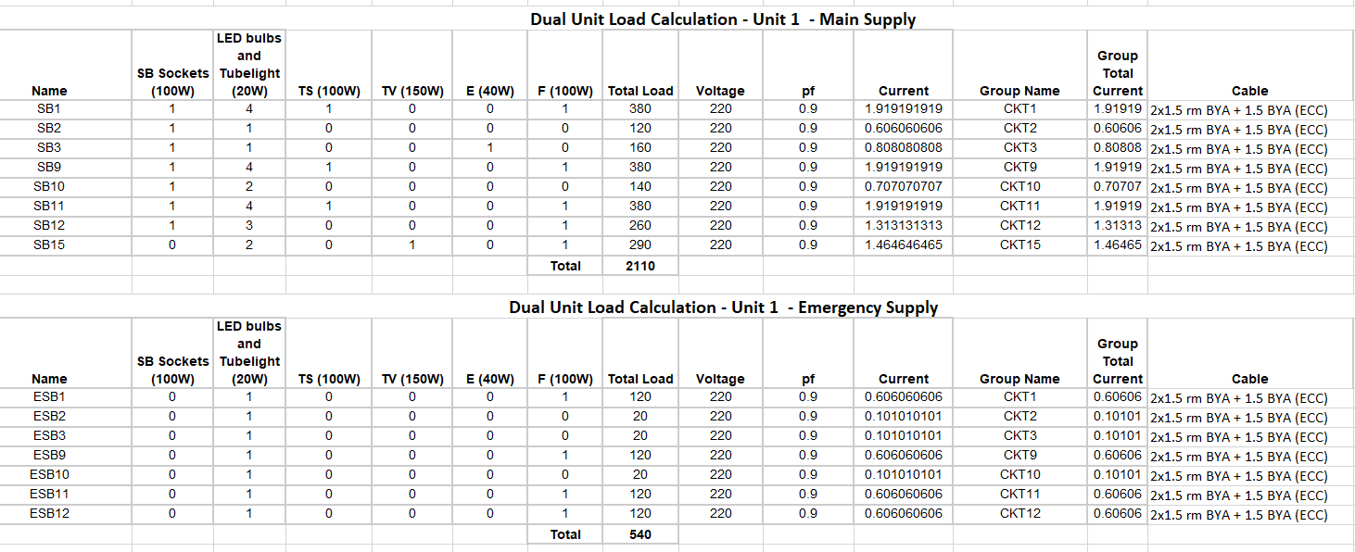

SDB Diagram and ESDB Diagram:

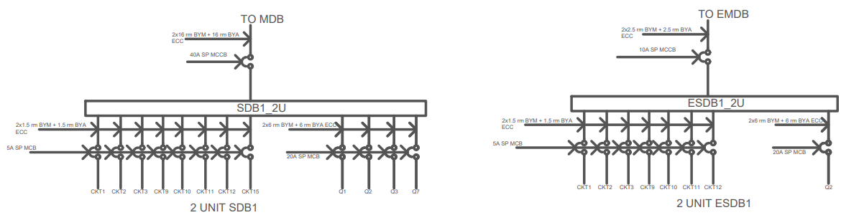

**Calculation:**

For SDB1_U2, we notice that all switchboards are below 5A rating (similarly for the emergency case, as load is even lesser). Thus, standard 2 x 1.5 rm BYM cables and 1.5 BYA ECC cable has been used for connecting switchboards to SDBs, along with 5A MCB breakers.

Here, power sockets with rating 20A and 4000W are present. (4000V/220A = 18.18A). Thus, we have used **20A SP MCB Breakers** and 2x6 rm BYM + 6 rm BYA ECC wires.

We assume utility factor for normal load to be 0.7, assuming they would be operating 70% of the time. And for power sockets, we assume utility factor to be 30%.

Here, power factor = 0.9

**SDB1_U2:**

Load = 0.7 x total load + 0.9 x power socket load  
= 0.7 x 2110 + 0.3 x 4000 x 4 = **6277W** (4 Q sockets are present)  
Current = 6277/(220 x 0.9) = 31.7 A  
Thus, 2 x 16 rm BYM cables and 16 rm BYA ECC cable has been used, along with 40A SP **MCCB** breaker, to connect it to the MDB.

**ESDB1_U2:**

For emergency condition, we will assume the power socket utility factor to be 0.2

Load = 0.7 x total emergency load + 0.2 x power socket load  
= 0.7 x 540 + 0.2 x 4000 = **1178W** (1 Q socket is present on emergency)  
Current = 1360/(220 x 0.9) = 5.95 A  
Thus, 2 x 2.5 rm BYM cables and 2.5 rm BYA ECC cable has been used, along with 10A SP **MCCB** breaker, to connect it to the MDB.

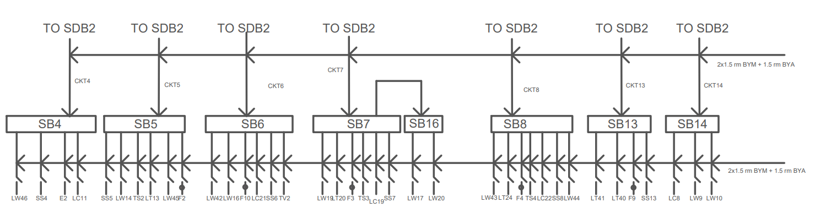**Double Unit Floor – Unit 2**

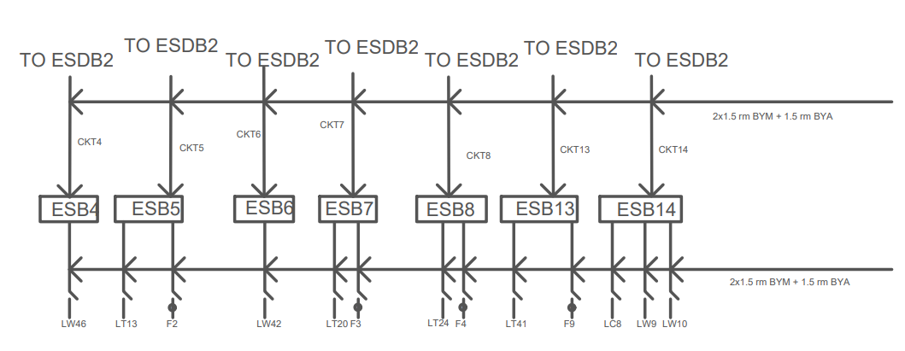 Switch Board Diagram and Emergency Switch Board Diagram:

Calculations:

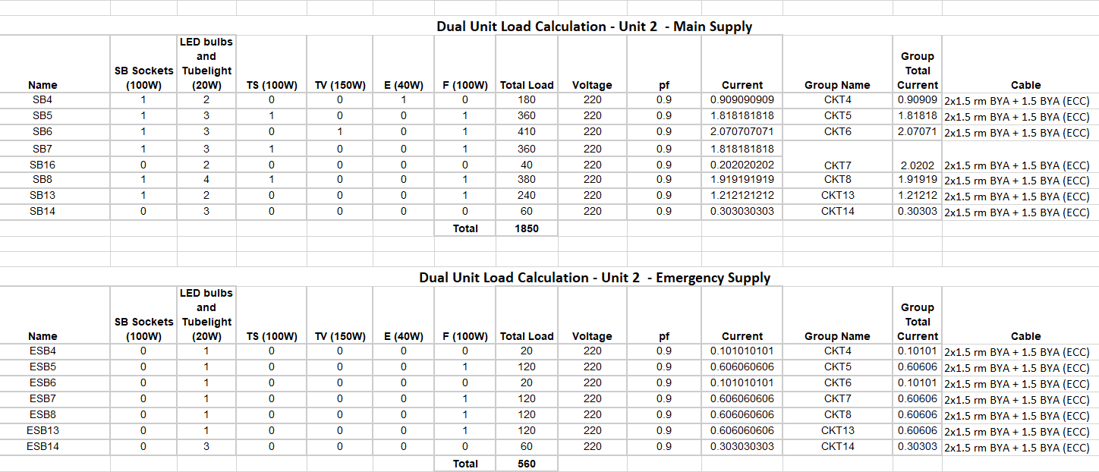

SDB Diagram and ESDB Diagram:

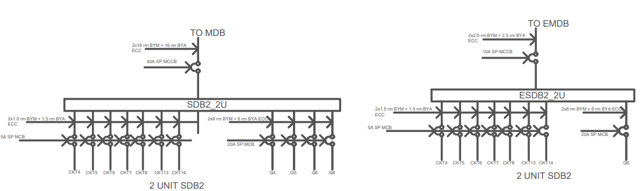

**Calculation:**

For SDB2_U2, we notice that all switchboards are below 5A rating (similarly for the emergency case, as load is even lesser). Thus, standard 2 x 1.5 rm BYM cables and 1.5 BYA ECC cable has been used for connecting switchboards to SDBs, along with **5A MCB breakers**.

Here, power sockets with rating 20A and 4000W are present. (4000V/220A = 18.18A). Thus, we have used **20A SP MCB Breakers** and 2x6 rm BYM + 6 rm BYA ECC wires.

We assume utility factor for normal load to be 0.7, assuming they would be operating 70% of the time. And for power sockets, we assume utility factor to be 40%.

Here, power factor = 0.9

**SDB2_U2:**

Load = 0.7 x total load + 0.9 x power socket load  
= 0.7 x 1850 + 0.4 x 4000 x 4 = **6095W** (4 Q sockets are present)  
Current = 7695/(220 x 0.9) = 30.78 A  
Thus, 2 x 16 rm BYM cables and 16 rm BYA ECC cable has been used, along with 40A SP **MCCB** breaker, to connect it to the MDB.

**ESDB2_U2:**

For emergency condition, we will assume the power socket utility factor to be 0.2

Load = 0.7 x total emergency load + 0.2 x power socket load  
= 0.7 x 560 + 0.2 x 4000 = **1192W** (1 Q socket is present on emergency)  
Current = 1192/(220 x 0.9) = 6.02 A  
Thus, 2 x 2.5 rm BYM cables and 2.5 rm BYA ECC cable has been used, along with 10A SP **MCCB** breaker, to connect it to the MDB.

**Roof**

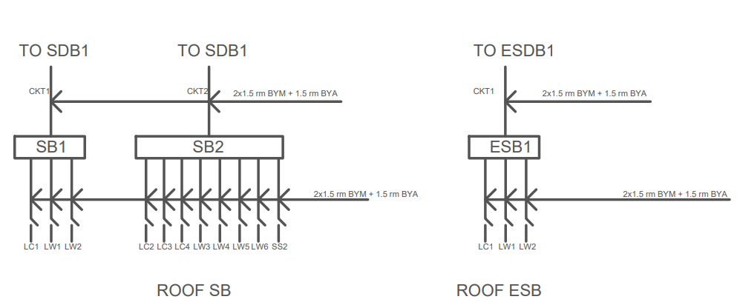Switch Board Diagram and Emergency Switch Board Diagram:

Calculations:

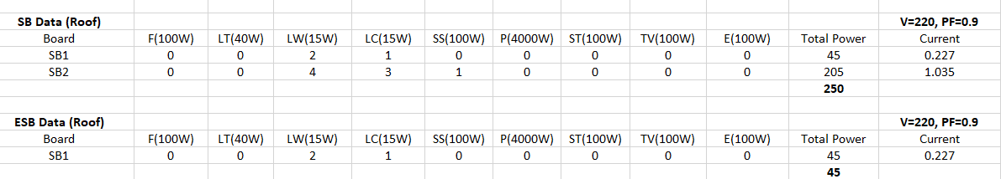

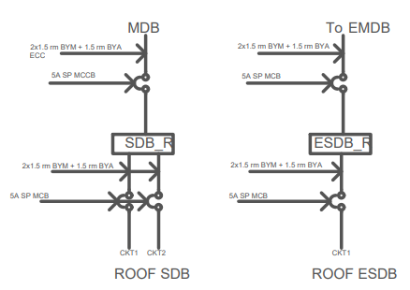SDB Diagram and ESDB Diagram:

**Calculation:**

For SDB_G, we notice that all switchboards are below 5A rating (similarly for the emergency case, as load is even lesser). Thus, standard 2 x 1.5 rm BYM cables and 1.5 BYA ECC cable has been used for connecting switchboards to SDBs, along with 5A MCB breakers.

We assume utility factor for normal load to be 0.7, assuming they would be operating 70% of the time. Power Factor = 0.9

SDB_R:

Load = 0.7 x total load = 0.7 x 250 = **175W** (No power sockets are present here)  
Current = 175/(220 x 0.9) = 0.88 A  
Thus, 2 x 1.5 rm BYM cables and 1.5 BYA ECC cable has been used, along with 5A SP **MCCB** breaker, to connect it to the MDB.

ESDB_R:

Load = 0.7 x total emergency load = 0.7 x 45 = **31.5W**  
Current = 31.5/(220 x 0.9) = 0.159 A  
Thus, 2 x 1.5 rm BYM cables and 1.5 BYA ECC cable has been used, along with 5A SP **MCCB** breaker, to connect it to the MDB.

**Main Distribution Board Calculation**

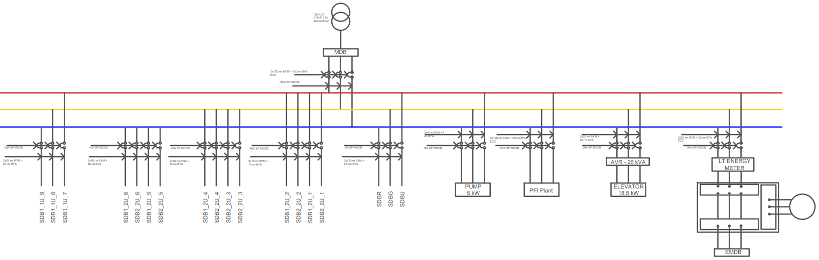

**The SDB loads are listed below:**  
SDB_U = 616 W  
SDB_G = 728 W  
SDB1_1U = 8464  
SDB1_2U = 6277  
SDB2_2U = 6095  
SDB_R = 175

Keeping in mind that 6 floors are dual units and 3 are single units, and we have installed extra Lift (18500 W) and pump (5000W), and utility factor = 0.7

Thus,

total MDB load = (SDB_U + SDB_G + SDB_R + 3x(SDB1_1U) + 6x(SDB1_2U + SDB2_2U) + Pump + Lift) x Utility Factor  
= 87.250 kW

As our Emergency system is not separate from the system supplied by the main, we don’t include EMDB loads in our MDB calculation, as it is already included.

Now,

I = P/3*V*PF = **146.89 A**​ (V=220 V, pf = 0.9)

Thus, we will need **2x120 rm NYY + 120 rm BYA ECC** wire and a **150 A SP MCCB** Breaker.

S =  P/pf = 96.944 kVA

We will need a **100kVA transformer substation**.

**Emergency Main Distribution Board Calculation**

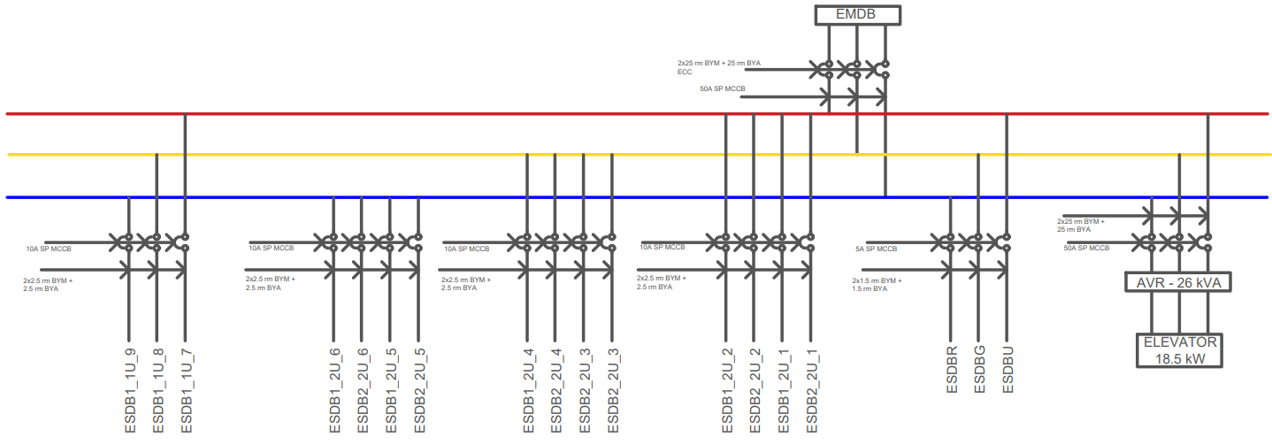

**The ESDB loads are listed below:**

ESDB_U = 378 W  
ESDB_G = 560 W  
ESDB1_1U = 1360  
ESDB1_2U = 1178  
ESDB2_2U = 1192  
ESDB_R = 31.5

total EMDB load = (ESDB_U + ESDB_G + ESDB_R + 3x(ESDB1_1U) + 6x(ESDB1_2U + ESDB2_2U) + Lift) x Utility Factor  
= 26.438 kW

I = P/3*V*PF = **44.51 A**​ (V=220 V, pf = 0.9)

Thus, we will need **2x25 rm NYY + 25 rm BYA ECC** wire and a **50 A SP MCCB** Breaker.

S =  P/pf = 29.38 kVA

Thus, a **40 kVA Generator** is to be used.

**PFI Plant**

Here, Q = Ptan(cos-1(pf)) = 87.250 tan(cos-1(0.9)) = 42.257 KVAR

The PFI plant needs to deliver this much capacitive reactive power to bring the power factor close to unity.

Thus, current = Q/3*V*sin(cos-1(pf)) = 146.88 A

We need to use 2x120 rm NYY + 120 BYA ECC wires along with 150A SP MCCB breakers.

**Elevator**

Power = 18500 W  
Let, pf = 0.7  
Thus, current = 18500 / 3*220*0.7 = 40.0432 A  
  
Thus, we need to use 2x25 rm NYY + 25 BYA ECC wires along with 50A SP MCCB breakers.

**Pump**

Power = 5000 W  
Let, pf = 0.7  
Thus, current = 5000 / 3*220*0.7 = 10.823 A  
  
Thus, we need to use 2x4 rm NYY + 4 BYA ECC wires along with 15A SP MCCB breakers.